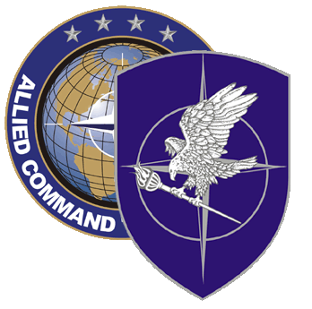
NATO SCHOOL: Global Leader in Multinational Military Education and Individual Training

S5-100 IRAQI OPERATIONS Center Personnel Command and Control Course

The aim of this course is to introduce and describe to Iraqi OPS Centre Personnel the role of C2 in Iraqi C3 structures and to distinguish between C2 planning and the process to fulfill C2 requirements. Additionally, the course will relate the use of C2 in operations and improve the student’s understanding of joint C2.

Course Length: 1 week

Offerings per year: 1

Class Size: Max 30 / Min 15

Security Clearance: NATO UNCLASSIFIED

Characterization of Students:

Military officers from rank of Captain to Major General from Iraqi MOD, chiefs of police officers from Iraqi MOI, and civilian equivalents.

Prerequisites:

- Nominated by NTM-I

- Language proficiency: Not required, instantaneous interpretation is provided

Course Objectives:

At course completion, the student should be able to:

- Describe the role of C2 in Iraqi C3 structures

- Explain C2 planning and the process to fulfill C2 requirements

- Describe the use of C2 in operations and comprehend the understanding of joint C2

